**VM Machine Description**

Virtual Machine Name: QBYMSQVDC001

Memory: 2048 Mb

Virtual Disk: qbymsqvdc001.vmdk (Max Size: 250 GB)

Operation System: Oracle Linux 6.1

Ping 192.168.1.10

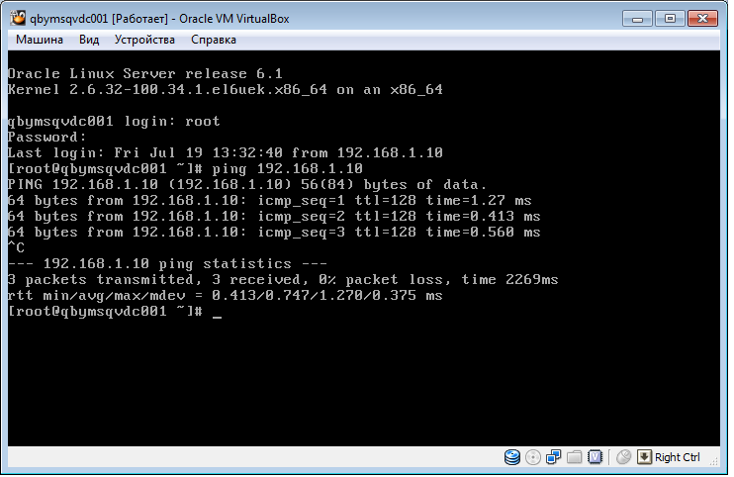

Free -b

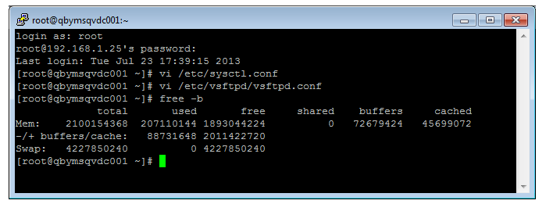

Sysctl.conf

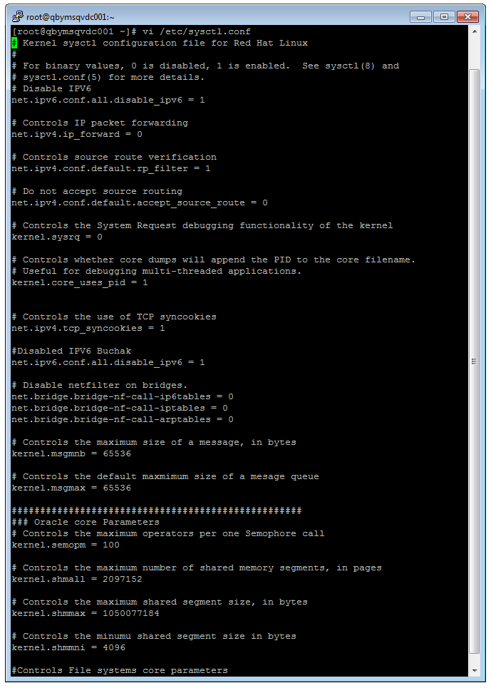

Vsftpd.conf

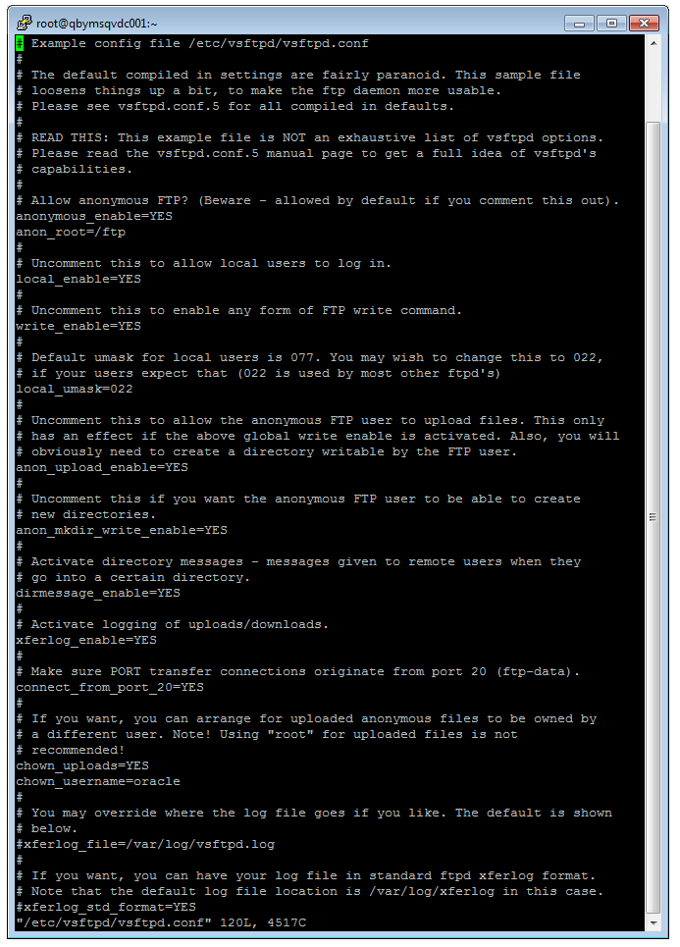

Bash_profile

